Iteration | ∆^{2i}_{P}(%) | ∆^{2i}_{Q}(%) | ∆^{2i}(%)
Base case | 0 | 0 | 0
1 | -17.01 | -22.92 | -19.97
2 | -20.86 | -34.76 | -27.81
3 | -23.77 | -50.28 | -37.02
4 | -25.51 | -58.00 | -41.75
5 | -26.04 | -73.86 | -49.95
6 | -26.21 | -77.70 | -51.96
TABLE 1. Global mismatch of proposed reservoir image with iterations.

Item | Iteration | Well 1 | Well 2 | Well 3 | Well 4 | Well 5 | Well 6 | Well 7 | Well 8 | Well 9
Global mismatch of each well | Base case | 0.504 | 0.023 | 0.028 | 0.158 | 0.003 | 0.100 | 0.001 | 0.169 | 0.013
Global mismatch of each well | 1 | 0.281 | 0.023 | 0.030 | 0.131 | 0.003 | 0.144 | 0.001 | 0.170 | 0.017
Global mismatch of each well | 2 | 0.177 | 0.023 | 0.031 | 0.132 | 0.003 | 0.191 | 0.001 | 0.144 | 0.021
Global mismatch of each well | 3 | 0.183 | 0.023 | 0.031 | 0.136 | 0.003 | 0.111 | 0.001 | 0.122 | 0.021
Global mismatch of each well | 4 | 0.183 | 0.024 | 0.032 | 0.083 | 0.003 | 0.110 | 0.001 | 0.125 | 0.022
Global mismatch of each well | 5 | 0.174 | 0.023 | 0.032 | 0.085 | 0.003 | 0.079 | 0.001 | 0.082 | 0.022
Global mismatch of each well | 6 | 0.176 | 0.023 | 0.032 | 0.087 | 0.003 | 0.052 | 0.001 | 0.085 | 0.022

TABLE 2. Global mismatch for each well with iterations.

FIGURE 1. Schematic procedure of the methodology.
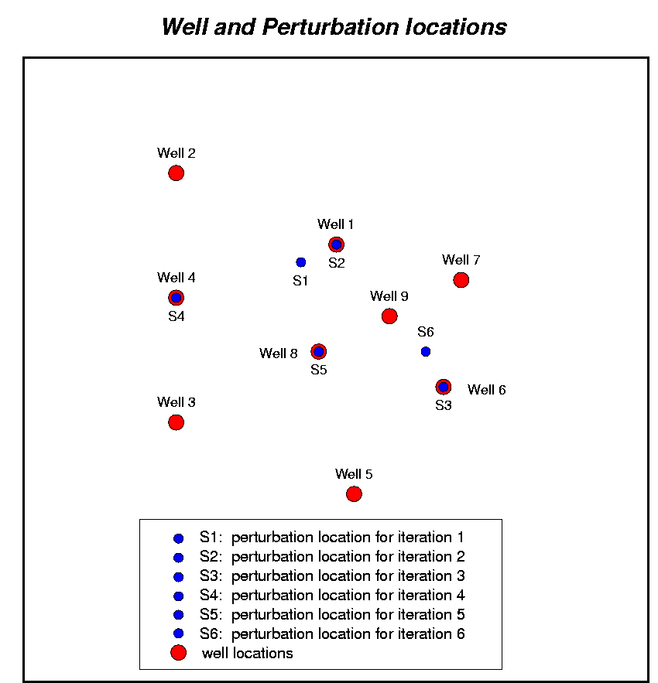

FIGURE 2. Well and perturbation locations.

FIGURE 3. Mismatch with iteration for Eclipse model A.

FIGURE 4. Oil rate and well bottom-hole pressure curves at four wells .
FIGURE 5. Global mismatch from simulations with different combinations
of property models and schedule files.

